Press Kit

August 11, 2025



Written and performed by
Chris Gibbs

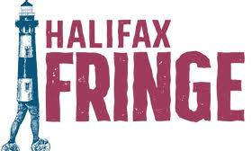
Halifax Fringe Festival
VENUE: DANSpace,
1800 Argyle St,
Halifax, B3J 2V9

SHOWTIMES:
Thursday August 28th - 5:30
Saturday August 30th - 10:30
Sunday August 31st - 1:00
Monday September 1st - 12:30
Wednesday September 3rd - 5:45
Saturday September 6th - 1:00

Media contact : Chris Gibbs, 647 654 3930
chris@thechrisgibbs.com

Synopsis:

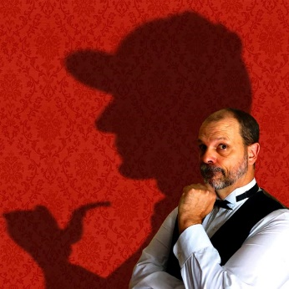
London, the final years of the nineteenth century. Barnaby Gibbs, a man made almost entirely of shortcomings, never expected to do anything useful with his life. But then he became the stalwart companion of the brilliant detective Antoine Feval, sharing in his adventures, and helping him solve the most difficult of mysteries.
But in all their investigations together, there is one mystery that has never been solved; why would a brilliant man like Feval choose to work with a bumbling fool like Gibbs?

In Not Quite Sherlock, veteran fringe performer Chris Gibbs uses every bit of his 35 years of comedy experience to tell the heart-warming and hilarious story of a man who thinks he must be the luckiest fellow on earth, but who might just have depths so hidden, only a genius could find them.

Not Quite Sherlock was first performed in 2005 at the Winnipeg Fringe Festival, where it won Best of Fest. Since then the show has been performed all over Canada (and a little bit beyond). It sold out its entire Toronto Fringe run in 2006, won the Just For Laughs Best Comedy Award in the 2009 Montreal Fringe, and then played at Just For Laughs that year. Other highlights include the Revolutions Festival in Albuquerque, NM, the High Performance Rodeo in Calgary, and the Victoria Playhouse, Victoria by the Sea, PEI.

Company Bio: Chris Gibbs

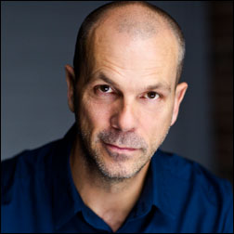
British comedian Chris Gibbs has been described as “comic genius” by the Globe and Mail, and “One of the funniest guys around” by the National Post. The Toronto Star has called his shows “darkly gleeful” and “comic stand-up gold”; and the CBC has described his delivery as “a combination of dry wit and barely controlled madness that threatens to go off the rails at any time”.

He has been performing since 1990, starting out as a street-acrobat in London’s Covent Garden. He first came to Halifax as one-half of the physical comedy duo Hoopal, performing at the Halifax Busker’s Festival in 2000. In 2002 he moved to Canada permanently and returned to Halifax to perform at what was then called the Atlantic Fringe with his first one-man show, ‘Gibberish’.

Since then he has created and continues to perform five more one-man shows; has won two Canadian Comedy Awards” Best Improv Troupe with ‘The Carnegie Hall Show’ and Best Comedic Play with ‘Plan “Live” From Outer Space’. He’s played at Just For Laughs in Montreal; appeared in two CBC Winnipeg Comedy Festival Galas; starred in the indie Canadian feature film, ‘Run Robot Run’ and is a published author. He’s even worked with Steven Spielberg, playing "Gizzardgulper", one of the evil giants in the Disney feature ‘The BFG’.



Not Quite Sherlock
PRESS RELEASE

Chris Gibbs, 647 654 3930, chris@thechrisgibbs.com

FOR IMMEDIATE RELEASE
August 11th, 2025 - Please include in your listings.

NOT QUITE SHERLOCK : AWARD-WINNING COMEDIAN AND FRINGE VETERAN CHRIS GIBBS RETURNS TO THE HALIFAX FRINGE AFTER FAR TOO LONG!

It’s been 23 years since British comedian Chris Gibbs last played at the Halifax Fringe. Since then he has created five more one-man shows and toured throughout the rest of Canada; directed several plays, including the 2016 Halifax Fringe hit Drag Queen Stole My Dress; won two Canadian Comedy Awards, Best Improv Troupe with The Carnegie Hall Show and Best Comedic Play with Plan “Live” From Outer Space. He’s appeared in Murdoch Mysteries, MayDay, and (very briefly) The Boys, and fulfilled every actor’s dream - working with Steven Spielberg! Chris played one of the evil giants in the Disney live-action movie, The BFG. I probably should have mentioned that one first. Now, he’s back in Halifax with his favourite one-man show, Not Quite Sherlock.

What’s it about?
London, the final years of the nineteenth century. Barnaby Gibbs, a man made almost entirely of shortcomings, never expected to do anything useful with his life. But then he became the stalwart companion of the brilliant detective Antoine Feval, helping him solve the most difficult of mysteries.
But in all their adventures together, there is one mystery that has never been solved; why would a brilliant man like Feval choose to work with a bumbling fool like Gibbs?

In Not Quite Sherlock, veteran fringe performer Chris Gibbs uses every bit of his 35 years of comedy experience to tell the heart-warming and hilarious story of someone who thinks he must be the luckiest man on earth, but who might just have depths so hidden, only a genius could find them.

Not Quite Sherlock was first performed in 2005 at the Winnipeg Fringe Festival, where it won Best of Fest. Since then the show has been performed all over Canada (and a little bit beyond). It sold out its entire Toronto Fringe run in 2006, won the Just For Laughs Best Comedy Award in the 2009 Montreal Fringe, and then played at Just For Laughs that year. Other highlights include the Revolutions Festival in Albuquerque, NM, the High Performance Rodeo in Calgary, The World Buskers Festival in New Zealand, and the Victoria Playhouse, Victoria by the Sea, PEI.

Not Quite Sherlock
Halifax Fringe Festival
VENUE: DANSpace, 1800 Argyle St, Halifax, B3J 2V9
Thursday August 28th - 5:30
Saturday August 30th - 10:30
Sunday August 31st - 1:00
Monday September 1st - 12:30
Wednesday September 3rd - 5:45
Saturday September 6th - 1:00

Media Contact :
Chris Gibbs
647 654 3930
chris@thechrisgibbs.com
Photo:

Download hi res image at notquitesherlock.com/presskit

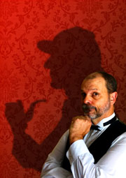

Press quotes:

“Gibbs’s performance is near flawless. His martini-dry wit is characteristically sharp, and his comic timing is beautiful.”
CBC

“Clueless, guileless and absolutely priceless…Sherlockians will be in heaven. Everyone else will be here, laughing hard.”
Edmonton Journal

“a masterpiece that manages to be both ridiculous and intelligent”
Vancouver Sun

“full of twists, turns, and gadzooks moments.”
Now Magazine, Toronto

“a highly skilled, confident comic actor whose writing is unrelentingly clever and whimsical”
Victoria Times Colonist

“one of the most cleverly written and performed shows I’ve ever seen at the Fringe.”
stage-door.com

